Parkwood Parent Teacher Association
1815 N. 155th Shoreline, WA 98133

Dear Parkwood Families, September 2018
Welcome to the new school year. This is going to be an exciting year as we make North City our temporary home and watch the new Parkwood take shape. During this transition it’s more important than ever that our families stay involved and continue to help our teachers and administrators cultivate the Parkwood community we’ve come to know and love.
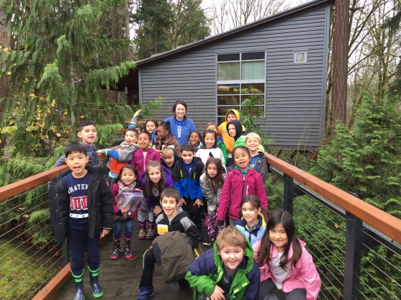
I am writing you today to invite you to join our Parent Teacher Association (PTA) and to participate in our ‘Invest in Parkwood’ Campaign. Our goal is to have 100% of our families join our PTA and to raise $18,000 between now and October 5th.

The Impact of your Donation

Your gift directly benefits your child’s education. With your help the PTA:

- Helps fund our library and educational enrichment opportunities inside and outside of the classrooms, such as fieldtrips and classroom speakers.
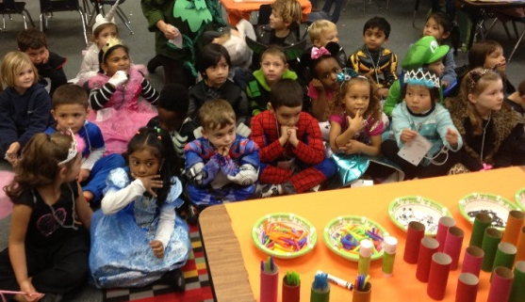
- Provides a grant of at least $200 to each classroom teacher for discretionary funding for creative projects.
- Supports community building events and programs such as Watch D.O.G.S., Parkwood classroom community networks, the Back to School BBQ & Welcome, Heritage Night, the annual Talent Show and more.
- Grants scholarships for participation in the Parkwood play, supports Parkwood families in need and The Works.
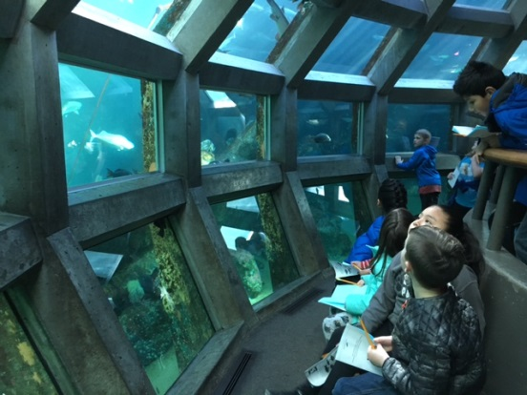
You know what an amazing school we have with teachers who go above and beyond to create a learning environment that brings out the potential in each child. That’s why we know we can count on you (and your families and neighbors) to invest in Parkwood!

Please…

- Review the Membership and Donation Form on the back of this letter.
- Join the Parkwood PTA at the level that makes sense to you.
- Consider what you as a family can afford to give back to our school. All gifts are welcome, no matter the size!
- Fill in the Donation Form and send it back to Parkwood PTA by October 5th.
  - Note that we do have monthly giving options available on our website http://www.parkwoodpta.org/get-involved/donate/.
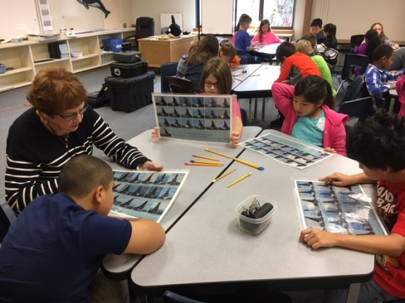
  - Just $10 per month ($2.50/week!) adds up to a $100 donation this school year!

It takes a village to raise and educate our children. Thank you in advance for joining our amazing village of supporters.

Christina Torres
Parkwood PTA Board President

Our kids and teachers are counting on us! Please fill in the Donation Form on the back and return it no later than 10/5.

