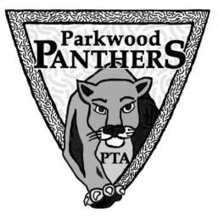
Parkwood Families…We Need Your Help!

The Parkwood PTA is sponsoring our annual spring Silent Auction and Talent Show on June 1st!

This is a fun evening to come and enjoy the many talents of our Parkwood community, while also getting the chance to bid on many items that you already use and want—but all of the proceeds go to Parkwood!

We are continuing our fabulous basket raffle tradition. For $1 anyone can buy a raffle ticket for a specific basket. First, however, we need to collect those basket items! We have assigned each grade level a basket theme.
Please choose an item (or more!) that matches the theme, and send it to school with your child between Monday, April 23rd and Friday, May 25th.
Basket Themes (Suggestions are listed but feel free to be creative!)
Kindergarten | Arts and Crafts Basket—paints, colored pencils, stamps, markers, paper, craft kits, paint canvases, coloring books, gift certificates to art/craft stores
1st grade | Chocolate, Coffee and Tea Basket—chocolate, coffee, teas, hot cocoa, marshmallows, mugs, teacups, gift certificates to coffee and tea shops.
2nd grade | Fiesta Basket— chips and salsa, spices, Mexican cookbooks, serving trays or bowls, table linens, gift certificates to Mexican restaurants.
3rd grade | Movie Night Basket – dvd movies, popcorn, bowls, snacks, candy, movie tickets, throw blankets, gift certificates to Redbox/Hulu/Amazon Video
4th grade | Spa Basket—soaps, bubble bath, lotions, cleansers, loofah, massage tools, candles, washcloth or hand towel, gift certificates
5th grade | Italian Night Basket—pasta, sauces, spices, cookbooks, table linens, fun Italian dishes, gift certificates to Italian restaurants
6th grade | Cupcakes/Baking Basket – baking mixes, pans, baking decorations, frosting, mixing spoons, cupcake wrappers, recipes or cookbooks

- There will be boxes in the front hallway beginning Monday April 23rd. You or your student can leave your basket donation in the boxes through Friday May 25th.
- What will the funds raised from the raffle be used for?
The PTA is working on funding more programs in the classroom including: Roots of Empathy, student field trips, teacher directed programs and hands on experiences. We are also working to raise money for scholarships so more families can participate in the afterschool enrichment classes.

Thank you for your help!

